 | Passport photo | Name | Roles | Mobile No.
 |  | Humphrey Andanyi Blessings | Founder and president/CEO | +18013195465
 |  | Tony Blair Kenedy | Vice president | +254796642850
 | 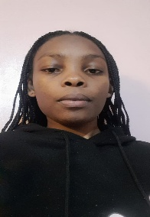 | Yvonne Otieno | PS -President | +254799238353
 |  | Faith Yator | PS -President | +254746534092
 | 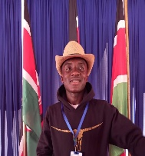 | Mandere Abednego | Sec General | +254769162548
 |  | Brian Cheruiyot | Vice Sec gen | +254716514818
 |  | Grace Kathure | Vice Sec Gen | +25419852237
 |  | Asole Bundara | Org Sec | +254700115193
 |  | Givens Onyango | Vice Org sec | +254716217645
 |  | Sammy Odhiambo | Vice Sec gen | +254759681956
 | 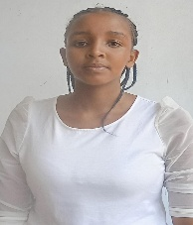 | Seby Sanaipei | National Treasurer | +254704169792
 |  | Isaac Wekesa | Vice Treasurer | +254798890765
 |  | Grace Nkirote | Director EC&S dept | +254111379171
 |  | Danny Ngatia | Director L$T Dept | +254750714191
 |  | Vicent Kamya | Director M&E Dept | +19599298610
 |  | Kepha Odhiambo | Director MH&A Dept | +254740244032
 |  | Joseph Chlein | Director, MG&C Dept | +254719595258
 |  | Lewis Ngugu | Director ICT & Media Dept | +254114971070
 |  | Joshua Menene | Director I&T Dept | +254753967606
 |  | Lyn Jerop | Director CS | +254715806866

